localectl Command
1) What is localectl? (History & Origin)
- localectl is a command used in Linux to manage system locale and keyboard layout.
- It is part of systemd, created by Lennart Poettering and Kay Sievers around 2010.
- Earlier, Linux used manual editing of /etc/locale.conf and /etc/vconsole.conf.
- localectl was introduced to make locale settings simpler and consistent.
2) Why is localectl useful for System Administrators?
- Helps set language, number format, date & time format, etc.
- Configures the keyboard layout for console or remote servers.
- Ensures consistent environment across users and services.
- Saves time by avoiding manual editing of config files.
- Works well with systemd-based distros (Ubuntu, Fedora, RHEL, CentOS).
3) How localectl works (with examples)
localectl updates system settings stored in:
- /etc/locale.conf → Locale settings
- /etc/vconsole.conf → Console keyboard settings
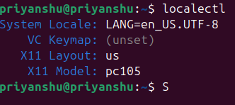
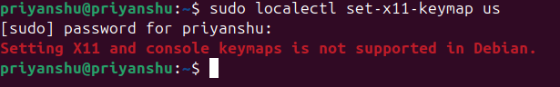

Options and flags
- status- shows current locale and keymap. 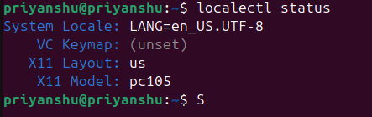
- set-locale- sets system locale. 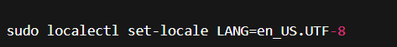
- set-keymap- sets keyboard layout for console. 
- set-x11-keymap- sets keyboard layout for graphical systems. 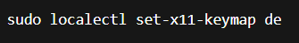
- list-locales- lists all installed system locales.
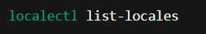
- list-keymaps- lists all available keyboard layouts.
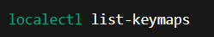
Source for detailed flags and options- https://www.freedesktop.org/software/systemd/man/localectl.html

kubectl get pods – Kubernetes pods
What is the kubectl get pods command? (History, invention, authors)
- kubectl is the official command-line tool for Kubernetes, used to manage clusters.
- Kubernetes was created by Google around 2014, later donated to the Cloud Native Computing Foundation (CNCF).
- The command kubectl get pods is used to show all pods running inside a Kubernetes cluster.
Why is this command useful for System Administrators?
System admins and DevOps engineers use this command to:
- Check the status of all running application pods.
- Know whether pods are Running, Pending, Failed, or CrashLoopBackOff.
- Troubleshoot deployments.
- Monitor the health and performance of applications.
- Confirm if new deployments or updates worked.
How does the command work?
kubectl get pods communicates with the Kubernetes API server, which returns information about pods in a cluster.
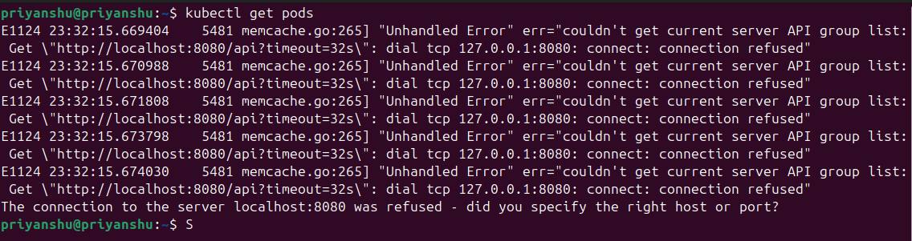
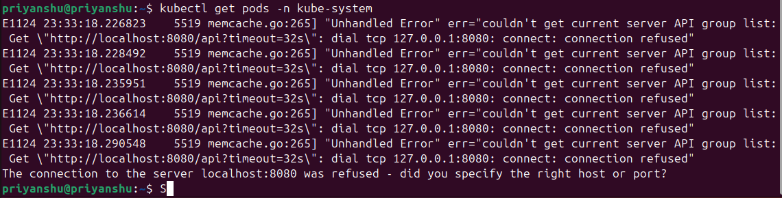
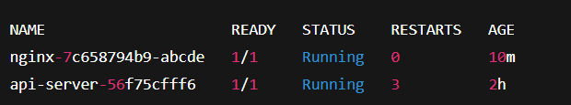
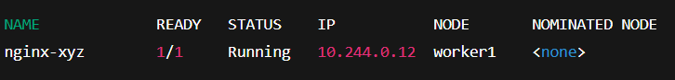
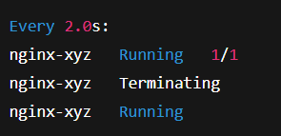
Options and Flags
- -n <namespace> - shows pods from a specific namespace. 
- -o wide - shows extra details like node name, IP, and images. 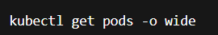
- -o json / -o yaml - outputs pod details in JSON/YAML format. 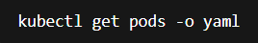
- –watch - monitors pod changes in real time.
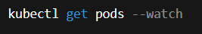
- --all-namespaces - shows pods from every namespace. 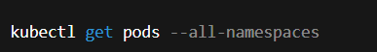
- -A - short form for --all-namespaces.


Source for detailed flags and options- https://kubernetes.io/docs/reference/generated/kubectl/kubectl-commands#get

